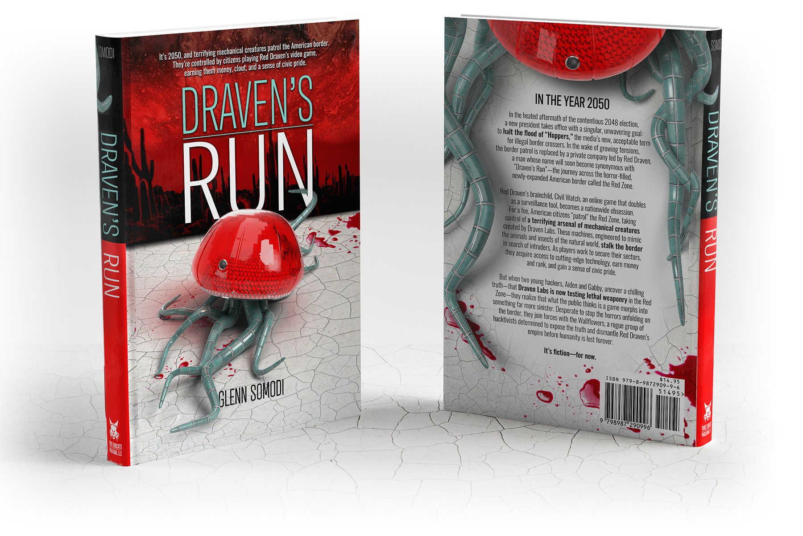

**CLEVELAND, OHIO – ENTERTAINMENT NEWS .**

**Border issues spark futuristic and thought-provoking theme in Glenn Somodi’s latest novel, ‘Draven’s *Run’***

Mechanical creatures patrolling our borders—controlled by citizens playing a video game? It’s fiction … for now.

**CLEVELAND, OHIO, APRIL 24th, 2025**

With his latest novel, **Draven’s Run**, award-winning Ohio author and illustrator Glenn Somodi offers a controversial and futuristic view of what the US Border might look like in 2050.

Somodi’s plot weaves together scary technological advancements, a citizen base obsessed with video games, and a hacktivist group determined to keep our borders open.

The novel carefully teeters between two views of immigration in the United States as epitomized by the Emma Lazarus inscription at the Statue of Liberty, “Give me your tired, your poor, your huddled masses … ,” and the quote from Geert Wilders, “Without sovereignty, a nation cannot exist. Without borders, it can’t be defined or protected.”

“I struggle with balancing my own two views on immigration,” Somodi said. “I am proud of my great-grandparents who entered the United States through Ellis Island, and I want others to share in that opportunity. But I also struggle with opening the borders to everyone. This book contains characters and plot lines representing both sides of this dilemma and offers a solution.”

“**Chilling, Clever, and Uncomfortably Plausible** - Draven’s Run is a gripping near-future thriller that blends dystopian tech, political tension, and fast-paced action. Glenn Somodi paints a believable 2050 where surveillance, nationalism, and gamification collide in terrifying ways. The concept of citizens piloting robotic border patrol creatures through a game-turned-surveillance system is both fascinating and disturbingly realistic.” *Read4Fun on Amazon*

***Draven’s Run*** features illustrations, including an inset with ten of Somodi’s 3D renderings depicting some of the book’s terrifying mechanical characters.

It is available through many online retailers and in local independent bookstores like Black Cat Books & Oddities in Medina, Ohio.

For a Microsoft Word copy of this release, more information, and high-resolution images, please visit www.DravensRun.com

###